Tools Required:
Power Drill/Driver, HSS Drill Bits – 3mm/7mm/8mm, Masonry Drill Bits – 6mm/8mm, Silicone Gun, Spirit Level, Mallet & Hammer, Step Ladders
Items Supplied:
Star Drive Bit, Posi Drive Bit, Silicone Sealant, Fixings, GutterGrid
Canopy Components
Glazing Bar | End Bar | Wall Plate
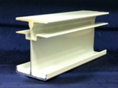 | 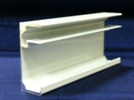 | 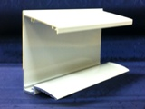
Eaves Beam/Gutter | Sheet End Trim | Canopy Post (Leg)
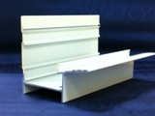 | 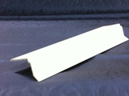 | 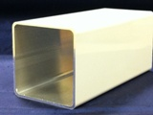

Prior to Installation, please ensure the following conditions have been met:

- The host wall and base should be made of a sound construction, suitable for fixing this system into position.
- Base for canopy posts should be of a solid concrete construction
- Fixings provided must be checked for suitability to your application before proceeding with installation.
We recommend the canopy is installed by two people due to the size and weight of certain components.
Step 1.0 Eaves Beam/Gutter preparation  Apply a bead of silicone sealant to the edge of the eaves/beam gutter. | 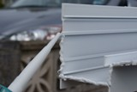 | Step 1.1 Eaves Beam/Gutter preparation  Fix the end cap to the end of the eaves/ beam gutter using the self tapping screws and cover cap provided. Wipe off excess silicone from outside edge.  NB do not fit screw“X” as this is fitted later. | 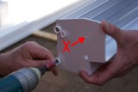
Step 1.2 Eaves Beam/Gutter preparation  Once the end caps are fitted, apply another bead of silicone to the inside edge | 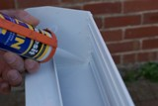 | Step 1.3 Eaves Beam/Gutter preparation  Determine and mark the position of the post legs on the underside of the eaves/ beam gutter. Select the drainage post/s and drill a central 40mm hole. NB. Alternatively a series of small holes can be drilled in a circular pattern to achieve the same result. | 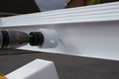
Step 1.4 Eaves Beam/Gutter preparation  To ensure leaves and debris do not block the water outlet, install a small section of gutter grid as per diagram. This can be fixed into position using a small bead of silicone if required. | 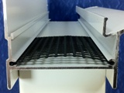 | Step 1.5 Eaves Beam/Gutter preparation  Once the pilot hole has been drilled permanently fix post/s into position using two self tapping screws per side. Ensure legs are square to eaves beam before screws are fitted. | 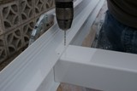
Step 2.0 Wall Plate Preparation  Determine the pitch required using the table provided on page 5, then measure and mark the host wall at the correct height. | NB all measurements shown are the height to underside of the wall plate  NB the dimensions are for standard 2.25m posts. For 3m posts add 750mm to the dimensions. | Step 2.1 Wall Plate Preparation  Using a 7mm HSS drill bit pre-drill the wall plate 100mm from the edge. Equally space the remaining fixing points along the wall plate and drill. We recommend minimum one fixing per glazing bar along the wall plate. | 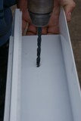
Step 2.2 Wall Plate Preparation  Apply a bead of silicone to the back of the wall plate. Offer up the wall plate to the wall and drill and fix the first hole into the wall using the 6mm masonry bit and fixings provided. NB fixings supplied are to be fixed into the brickwork with no plug. Do not fix into mortar joint. | 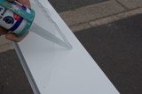 | Step 2.3 Wall Plate Preparation  Ensure the wall plate is level and fit remaining fixings and cover caps. Apply a bead of silicone to the top edge of the wall plate to form a watertight seal. | 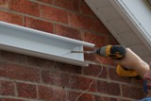
Step 3.0 Erecting The Canopy  The two edge bar profiles are to be fixed onto the wall plate and eaves beam using the self tapping screws provided. Use one screw at either end of the bar at this point to allow movement for squaring up later in the procedure. | 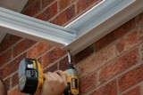 | Step 3.1 Erecting The Canopy  The drill guide lines on the underside of the wall plate and eaves beam denote the degree of pitch, reading from the host wall from 5 through to 20 degrees. (5 degree wall plate fixing shown opposite). | 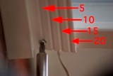
Step 3.2 Erecting The Canopy  Fit the pvc sheet end closure centrally to both ends of the polycarbonate panels. NB the printed film on the panels denotes the top sun (outer) side. The perforated foil tape should be at the gutter end of the roof. | 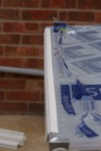 | Step 3.3 Erecting The Canopy  Engage the edge of the first polycarbonate panel into the glazing jaw on the edge bar and push the panel in firmly. Then select a glazing bar and engage the panel into the glazing jaw. Ensure the bar is then fully engaged into the wall plate. NB do not secure any of the glazing bars at this point. | 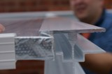
Step 3.4 Erecting The Canopy  Repeat the bar fitting procedure with all the remaining panels and glazing bars until one panel remains. Now remove the edge bar to allow access of the last panel and then refit. Structure now needs to be squared up. PVC end closures should be flush to wall plate. Now secure all glazing bars using two screws at both ends of each bar. | 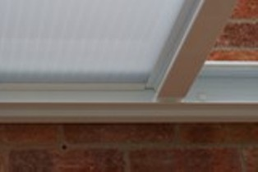 | Step 4.0 Fixing Posts  Once the structure is square, level the posts in both directions using a spirit level. Drill the concrete pad using an 8mm masonry bit and fix post brackets to the concrete base using the stud anchors supplied. | 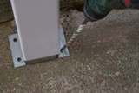
Step 4.1 Fixing Posts  Hammer in fixings and tighten with a 13mm spanner. Check fixings are secure for your base. | 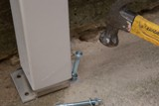 | Step 4.2 Fixing Posts  Level the gutter by adjusting the post over the foot bracket. Once the desired position is achieved, secure using two screws & caps either side of the post. | 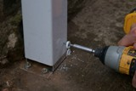
Step 5.0 Fitting Sheet Edge Trim  Apply a bead of silicone to the leading edge of the pvc sheet end closure at the gutter end of the canopy to ensure it is sealed onto the glazing material. | 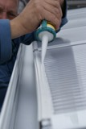 | Step 5.1 Fitting Sheet Edge Trim  Position the sheet edge trim profile on top of the glazing bar ends leaving a 10mm gap for water drainage at the end of the sheet. | 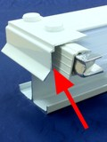

Step 5.2 Fitting Sheet Edge Trim  Using the screws and caps supplied. Use the sight line on the glazing bars to determine drill position. Use one screw per end bar and two per glazing bar. | 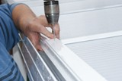 | Step 5.3 Fitting Sheet Edge Trim  Apply a bead of silicone in front of the edge trim over the glazing bar. Fix screw “X” into position (see step 1.1) and fit wall plate end caps.  This now completes the installation of the canopy. | 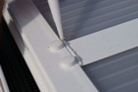

Wall plate preparation table
Pitch (degs) | Projection | 1500mm | 2000mm | 2500mm | 3000mm | 3500mm | 4000mm
5 |  | 2417mm | 2460mm | 2504mm | 2547mm | 2591mm | 2634mm
10 |  | 2543mm | 2630mm | 2717mm | 2804mm | 2890mm | 2977mm
15 |  | 2665mm | 2795mm | 2924mm | 3054mm | 3183mm | 3312mm
20 |  | 2784mm | 2955mm | 3126mm | 3297mm | 3468mm | 3639mm

Disclaimer
The manufacturer accepts no responsibility for any injury or consequential losses caused by the use of unsuitable fixings or by installation of the product in any way that differs from that described herein. Evolution canopies are designed to withstand a loading of 600 N/m2 which is suitable for most domestic applications in the United Kingdom. If you are installing the canopy in an exposed location please call your supplier to ask about increased loading specifications.

Please refer to www.molan-uk.com for a downloadable colour version of the fitting instructions.

